Pedagogy and Experience, NaturesCultures and Transformation -
Listening to the Sense of Hearing

One's own experience and reflection are - not surprisingly - the basis of every educational process: It is in the engagement of self and world that the self forms and the self shapes the world. We will begin the week with fundamental reflections on the philosophy of education, we will test experiential and environmental pedagogical interventions, and we will explore the possibility of medial mediation of I and nature. In this three-step process we want to ask which relationship to nature we live in everyday life and which relationship is appropriate.
The study week will focus on the sense of hearing. It is the central sense of our perception of the world and we want to explore it theoretically and practically, because listening is also an essential competence within social work. The psychologist Friedemann Schulz von Thun coined the four-sided model or the "communication square". Every communication can be described under four aspects, as factual content, self-disclosure, relationship and appeal. On all levels people can misunderstand or overhear each other. Also the non-human nature can be heard by humans, we will pursue the research question in the seminar and examine whether humans are also with the non-human nature in a communication square. Especially in spring, nature reveals a lot to the attentive listener. We will experience the power of listening in an excursion to a mountain hut and consider the experiential educational and social work potentials of listening.
We will start in the lecture hall of the university with an introduction to the phenomenology of hearing, then learn how to use a recording device and will produce a radio play in a small expedition that will take us to a rustic hut in the nearby Alps for two days, which will make nature and culture audible. To do this, we humans must first become quiet and still, because otherwise nothing can be heard: trees, wind, streams, birds, game and even fire need silence so that they can be heard, perhaps even understood. Let us be surprised what this means...
In Benediktbeuern you will be accommodated in the youth hostel directly at the university, both are located in the baroque monastery complex. There we will also be catered for during the days. Up to the alpine hut on about 1000m height we walk on the second day about 2.5 hours from the university. Here we feed ourselves and sleep in mattress camps (bring sleeping bags!). If the weather already allows it, we will also be able to climb the Benediktenwand (1801 m). An environmental and adventure educator will accompany us. Back at the University we will produce the audio pieces. We will also visit the cosmopolitan city of Munich and explore the rich culture of Upper Bavaria.
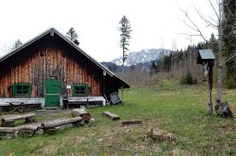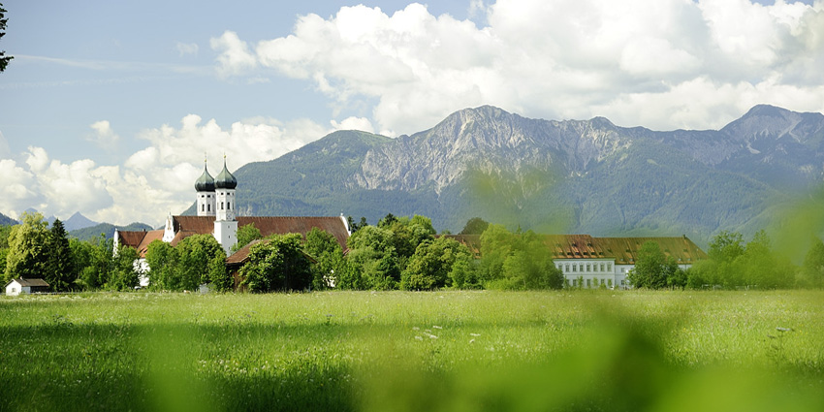

Monday | Tuesday | Wednesday | Thursday | Friday | Saturday | Sunday
 |  | 12.04.2023  Arrival  - Welcome Reception | 13.04.2023  - Phenomenology of Hearing and Listening  - Afternoon: Podcasting – History and Techniques – Soundscapes (at Institute for Media Research and Media Education, Munich)  Evening: Exploring Munich’s nightlife | 14.04.2023  - Philosophy and History of Human-Nature-Relationships  - Afternoon: Hiking to the Kohlstattalm Mountain Hut (2,5 hours walk) | 15.04.2023  Outdoor  Mountain Hut  - Sound Recording  - Outdoor and Environmental Education Methods in the Alpine Context | 16.04.2023  Outdoor  Mountain Hut  - Sound Recording  - Outdoor and Environmental Education Methods in the Alpine Context  Hiking back to Campus Benediktbeuern
17.04.2023  Media  - Podcast-Production | 18.04.2023  Culture  - Visit of Murnau and its Münter-house (where Wassily Kandinsky lived and painted)  - Visit to Diakonie Herzogsägmühle (a “social village”) | 19.04.2023  Departure

